Game Script – Detailed Design
Note: This document provides an English, journal-ready translation of the original Chinese design brief for the exergame system. Terminology has been standardized for international readership while preserving the original intent and structure.
1.Overview
This document outlines the game script and interaction design for a lower-limb training exergame themed “Tortoise and Hare Race” The specification defines the interface elements (on-screen informational overlays and controls), the gameplay loop (at the player-experience level), and the training modules targeted for implementation and evaluation. While the original project assets are in Chinese, the present file provides an English description suitable for international readership. In the game, the player assumes the role of the tortoise and competes against the hare.
2. Interaction Interfaces
2.1 Interface List
• Cover Page
• Loading Screen
• Home (Personal Information): Name, Gender, Age
• Tutorial： Device-wear tutorial video
• Profile Center: Overall exercise score and ranking, badges, per-session duration
• User-Selected Training Mode: Warm-up, Strength, Balance
• Preset Training: Ankle Joint → Knee Extension → Hip Abduction → Tiptoe→ Knee Flexion→ Single-Leg Stance
2.2 Entry and Progression
At game start, a loading progress bar is displayed. Upon completion, users fill in personal information. The “Tortoise-and-Hare Race” is then initiated. In Basic mode, earning a total score of 100 grants a badge; in Intermediate mode, reaching 150 grants a badge; in Advanced mode, reaching 180 grants a badge. Collecting 12 badges unlocks a real-world reward.
3. Training Modules and Game Logic
3.1 Ankle Joint Training – Balloon Pump Race
Timing Constraints: duration per repetition ≥ 2 s; rest 10 s after each set; normal completion time within 3–4 minutes (including rests).
Player Actions
Seated on a chair with backrest: extend the right leg, then perform one cycle of dorsiflexion followed by plantarflexion to count as one repetition. Repeat 10 times per leg, 20 in total. Complete three sets; rest 10 s between sets. Recommended ranges: plantarflexion 25°–45°, dorsiflexion 20°–30°.
Tortoise (Avatar) Logic
The tortoise stands with a foot-operated air pump connected to a balloon. When the player extends the leg and begins dorsiflexion, the tortoise mirrors the movement to ‘charge’ the pump. During plantarflexion, the tortoise presses the pump; the balloon inflates by one increment per press. At 10× baseline size, the system prompts a leg switch; at 20×, the balloon bursts. Bursting the balloon within 4 minutes counts as a win.
Hare (Opponent) Logic
• Basic: Co-pumps with the tortoise; falls asleep at the 10th, 30th, and 50th presses; resumes after each 10 s nap. • Intermediate: Sleeps at the 30th and 50th presses with 10 s naps. • Advanced: Sleeps at the 50th press with a 10 s nap, as shown in Figure 1.
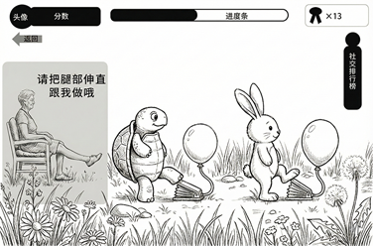
a
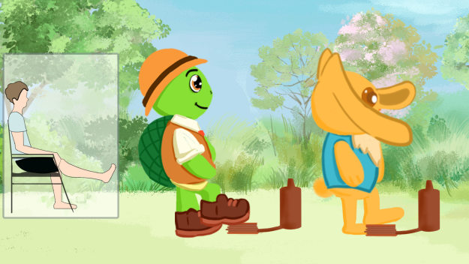
b
Figure 1. Main interface of the ankle-joint training game: (a) concept sketch; (b) finalized design
Intermission Screen
After each set, a “Take a Break” overlay appears with a 10 s countdown, as shown in Figure 2.
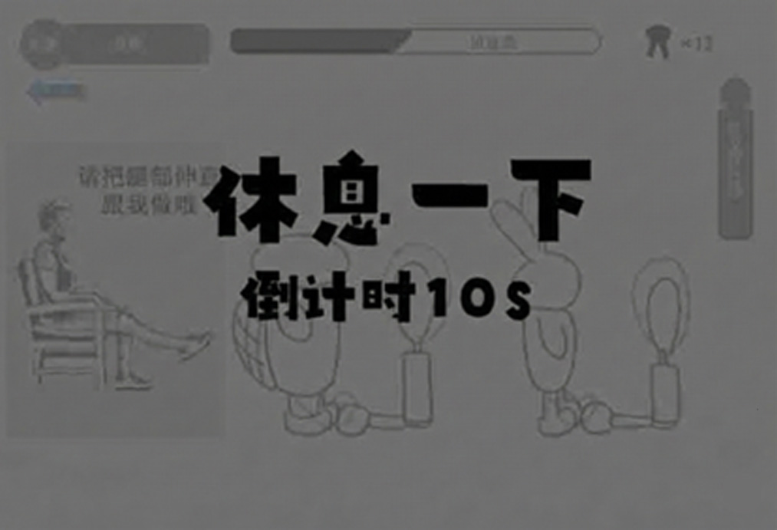
Figure 2. Intermission break interface design
Completion Screen
Main view desaturates; a framed scene shows the tortoise and hare together. — If the tortoise wins: confetti effects; the tortoise jumps and raises its hand; caption and audio: “Victory—Well done!”, as shown in Figure 3.
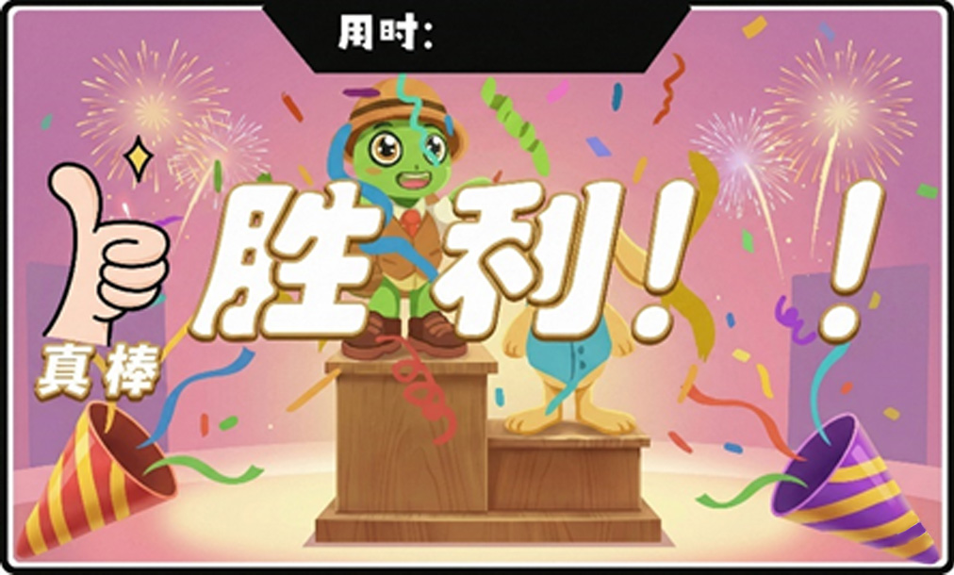
Figure 3. Victory screen design
The hare appears disappointed. — If the hare wins: screen desaturates; the hare celebrates with “Defeat” caption and a low-tone audio cue; the tortoise appears crying , as shown in Figure 4.
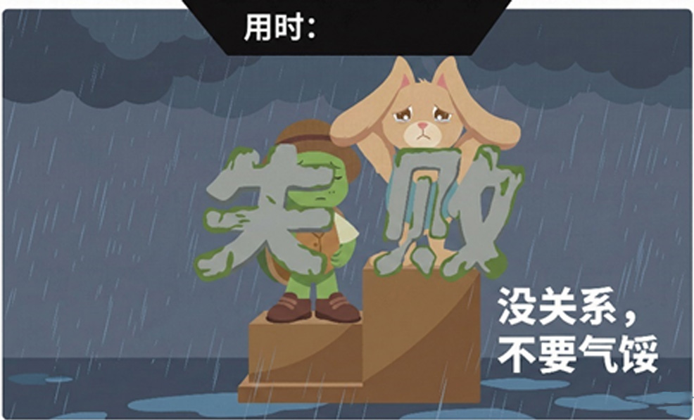
Figure 4. Defeat screen design
Knowledge Card
Upon completing ankle training, a 1-minute ‘Ankle Training Knowledge’ segment is presented as a transition , as shown in Figure 5.

Figure 5. Ankle-joint training knowledge screen design
3.2 Knee Extension Training – Standing Bag Kicks
Timing Constraints: duration per repetition ≥ 5 s; rest 10 s after each set; normal completion within 6–7 minutes (including rests).
Player Actions
Seated with backrest: thighs parallel to the floor, shanks vertical. Extend the knee to 45°–90°, hold for 3 s, then return to start to count as one repetition. Perform 10 repetitions per leg, 20 total. Complete three sets; rest 10 s between sets. Target extension range: 45°–90°.
Tortoise (Avatar) Logic
A free-standing punch bag is positioned next to the tortoise. When the player lifts the right leg, the tortoise retracts the right leg; during the 3 s hold the tortoise ‘charges,’ and when the player returns the leg to start, the tortoise kicks the bag. Ten kicks per leg; the system prompts a leg switch. Completing 20 kicks within 7 minutes beats the hare.
Hare (Opponent) Logic
• Basic: Co-kicks with the tortoise; sleeps at the 10th, 30th, and 50th kicks; resumes after each 10 s nap. • Intermediate: Sleeps at the 30th and 50th kicks with 10 s naps. • Advanced: Sleeps at the 50th kick with a 10 s nap , as shown in Figure 6.
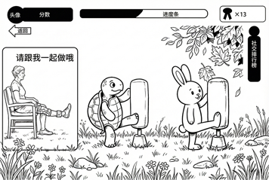
a
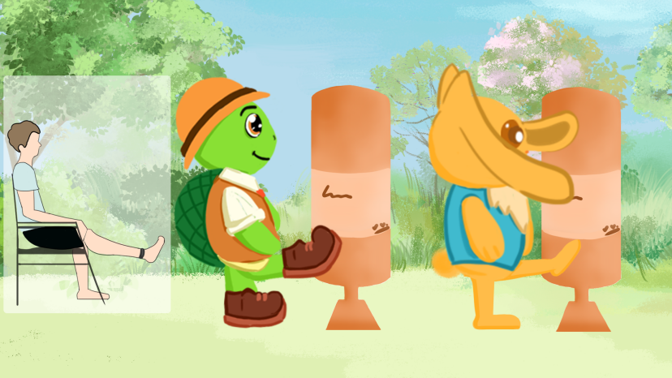
b
Figure 6. Knee extension training game main interface design: (a) concept sketch; (b) final design
Intermission/Completion/Knowledge
Intermission: 10 s “Take a Break” countdown after each set. Completion: same as Ankle module. Knowledge: a 1-minute ‘Knee Extension Knowledge’ segment as transition , as shown in Figure 7.

Figure 7. Knee extension training—knowledge screen design
3.3 Hip Abduction Training – Cliffside Tightrope Walk
Timing Constraints: duration per repetition ≥ 4 s; rest 10 s after each set; normal completion within 5–6 minutes (including rests).
Player Actions
Standing with the left hand on a support and the right hand on the waist, side-on to the support: extend the right leg straight to the right and abduct the right hip; hold for 3 s, then return to the starting position (one repetition). Repeat on the left side. Ten repetitions per side (20 total); complete three sets with 10 s rest intervals. Target hip abduction range: 25°–45°.
Tortoise (Avatar) Logic
The tortoise initially holds onto a cliffside tightrope with both hands while standing on another rope. When the player abducts the right leg, the tortoise steps to the right; during the 3 s hold the tortoise maintains balance; when the leg returns, the tortoise brings the left leg to meet the right. After 10 steps, the system prompts a switch; the tortoise then returns leftward to the origin for a total of 20 steps. Whoever returns to the origin first—tortoise or hare—wins.
Hare (Opponent) Logic
• Basic: Co-walks the rope; sleeps at the 10th, 30th, and 50th steps; resumes after each 10 s nap. • Intermediate: Sleeps at the 30th and 50th steps with 10 s naps. • Advanced: Sleeps at the 50th step with a 10 s nap , as shown in Figure 8.
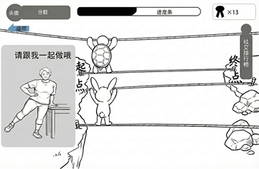
a
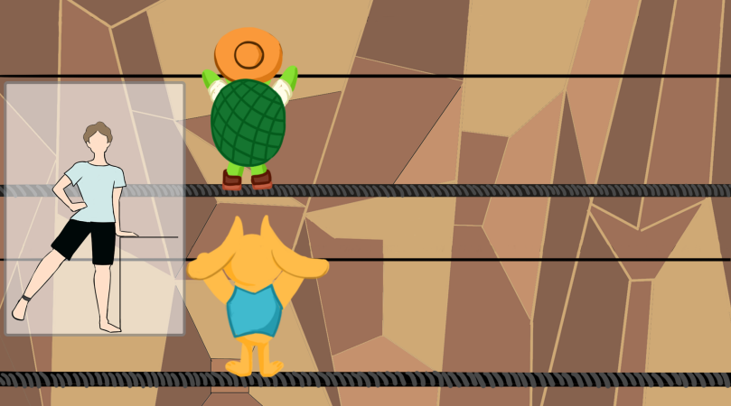
b
Figure 8. Hip abduction training game main interface: (a) concept sketch; (b) final design
Intermission/Completion/Knowledge
Intermission: 10 s “Take a Break” countdown after each set. Completion: same as above. Knowledge: a 1-minute ‘Hip Abduction Knowledge’ segment as transition , as shown in Figure 9.
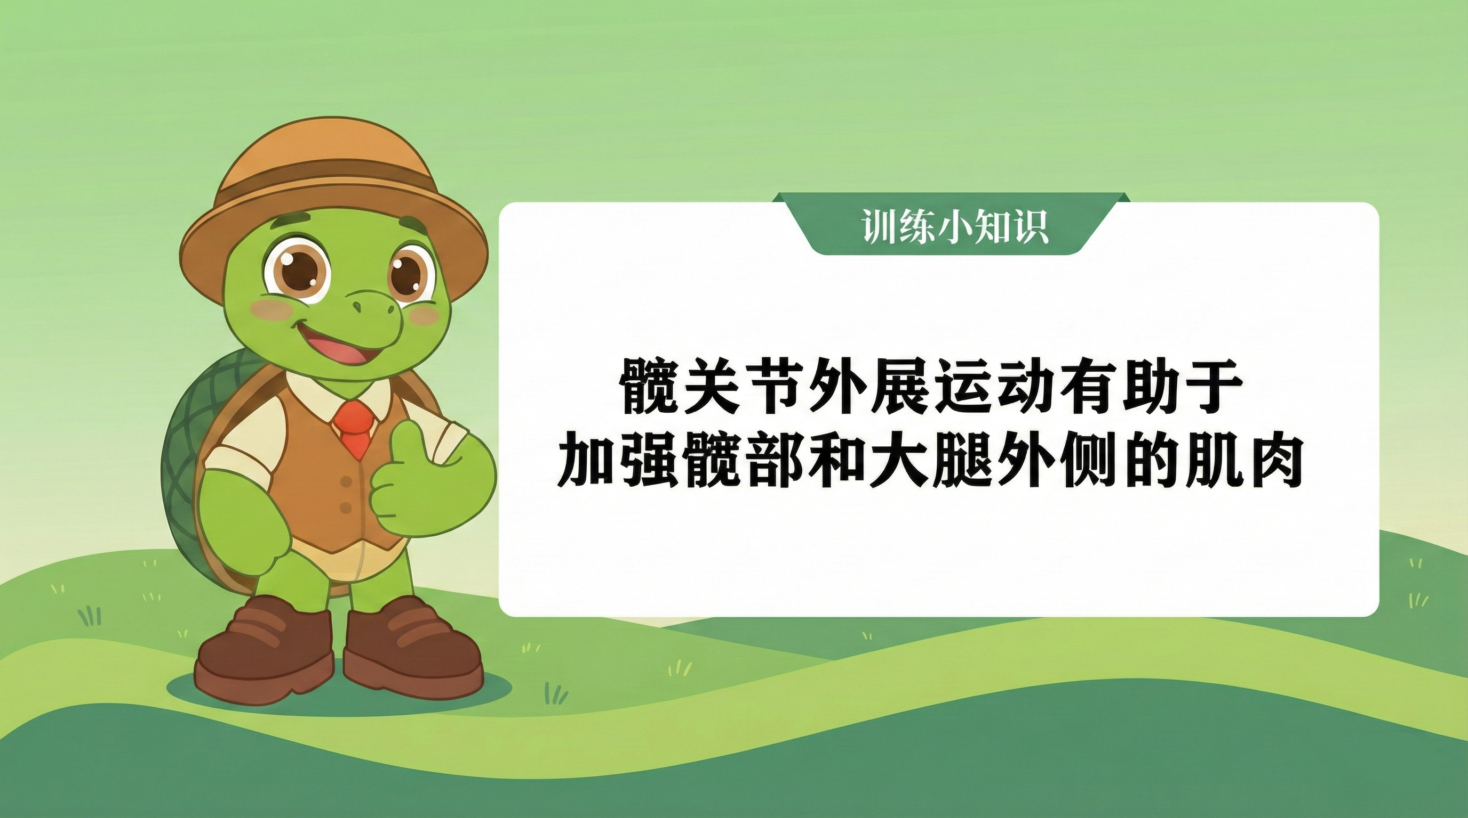
Figure 9. Hip abduction training knowledge screen design
3.4 Tiptoe Training – Iceberg Climb
Player Actions
With a support tool in front, stand facing forward, eyes level, feet shoulder-width apart. Raise both heels to stand on the toes, then return to start (one repetition). Repeat 25 times.
Tortoise (Avatar) Logic
Both avatars start in the ocean at the base of an iceberg. Each time the player rises onto the toes and returns, the tortoise climbs upward; inactivity causes the tortoise to slide downward toward the sea. The first to reach the top wins.
Hare (Opponent) Logic
Hare difficulty logic: • Basic: Climbs with the tortoise; rests for 5 s at the 5th, 10th, and 15th climbs, sliding slightly during rests, then resumes. • Intermediate: Rests for 5 s at the 10th and 15th climbs. • Advanced: Rests for 5 s at the 15th climb , as shown in Figure 10.
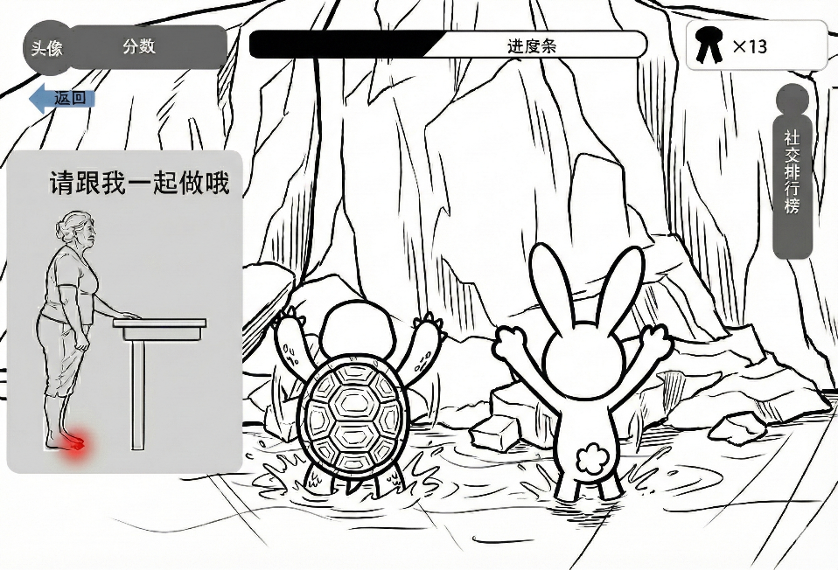
a
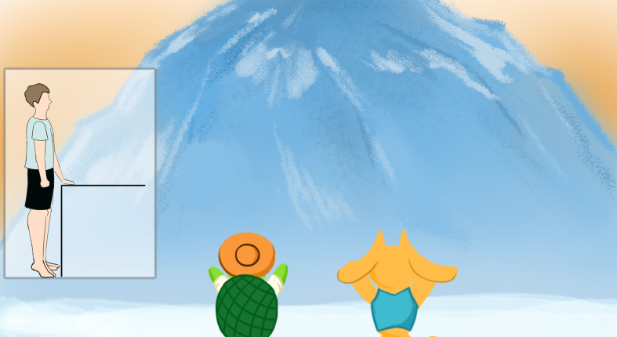
b
Figure 10. Tiptoe training game main interface design: (a) concept sketch; (b) final design
Intermission/Completion/Knowledge
Intermission: 10 s “Take a Break” countdown after each set. Completion: as above. Knowledge: 1-minute ‘Tiptoe Training Knowledge’ segment as transition , as shown in Figure 11.

Figure 11. Tiptoe training knowledge screen design
3.5 Knee Flexion (Squat) Training – Star Catch
Timing Constraints: duration per repetition ≥ 2 s; rest 10 s after each set; normal completion within 2–3 minutes (including rests).
Player Actions
With a support tool, stand with feet shoulder-width apart. Perform a controlled squat by flexing the knees until the knee line approaches or slightly exceeds the toe line; when the heels tend to lift, return to start (one repetition). Perform 10 repetitions per set; complete 3 sets with 10 s rests. Target knee flexion: 30°–60°.
Tortoise (Avatar) Logic
Two trampolines appear; the tortoise and hare each stand on one. Ten stars appear above each avatar. There are three sets of 10 stars (30 total); the first to collect all 30 wins.
Hare (Opponent) Logic
Hare difficulty logic: • Basic: Jumps with the tortoise; sleeps at the 10th, 20th, and 30th jumps; resumes after each 5 s nap. • Intermediate: Sleeps at the 20th and 30th jumps, 5 s each. • Advanced: Sleeps at the 30th jump, 5 s , as shown in Figure 12.
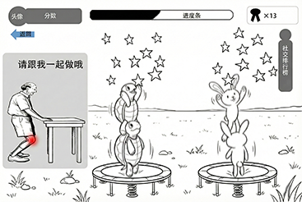
a
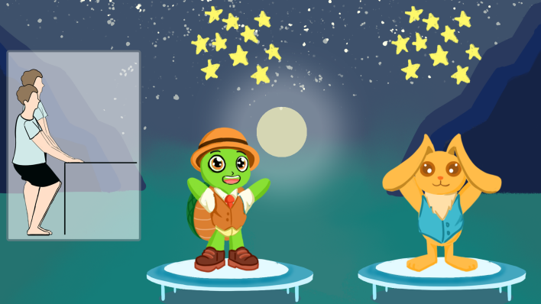
b
Figure 12. Knee flexion training game main interface: (a) concept sketch; (b) final design
Intermission/Completion/Knowledge
Intermission: 10 s break overlay after each set. Completion: as above. Knowledge: a 1-minute ‘Knee Flexion Knowledge’ segment as transition , as shown in Figure 13.

Figure 13. Knee flexion training knowledge screen design
3.6 Single-Leg Stance Training – Ninja on Piles
Timing Constraints: duration per repetition ≥ 10 s; rest 10 s after each set; normal completion within 2–3 minutes (including rests).
Player Actions
With handrail assistance: hold the rail with one hand; perform single-leg stance on the right leg for 10 s with eyes forward (one repetition). Switch legs thereafter. Ten repetitions per side (20 total); complete 3 sets with 10 s rest intervals.
Tortoise (Avatar) Logic
The tortoise and hare take on ninja poses on stone piles. When the player starts a repetition, the tortoise assumes a ninja stance and closes its eyes for single-leg balance. When switching legs, the tortoise maintains the pose. If the player fails to hold for 10 s, the tortoise loses balance and falls—counted as a failure.
Hare (Opponent) Logic
Hare difficulty logic: co-stands with the tortoise; sleeps at the 10th, 30th, and 50th trials for 5 s each, then resumes , as shown in Figure 14.
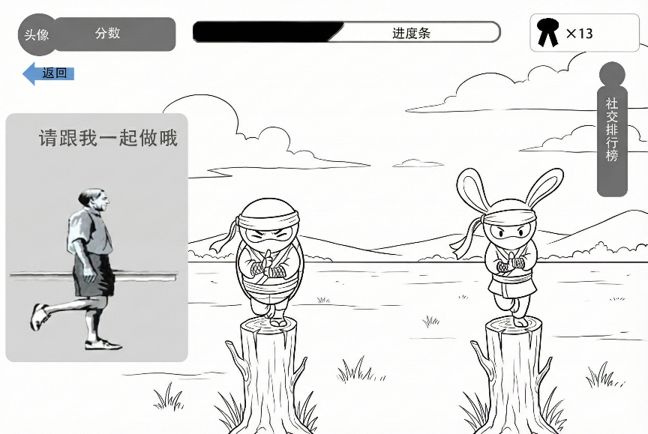
a
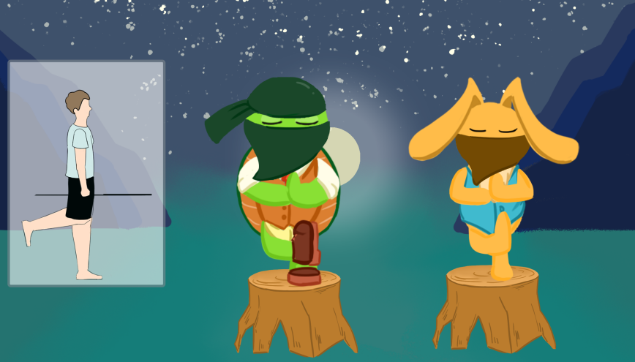
b
Figure 14. Single-leg stance training game main interface design: (a) concept sketch; (b) final design
Intermission/Completion/Knowledge
Intermission: 10 s “Take a Break” overlay after each set. Completion: as above. Knowledge: a 1-minute ‘Single-Leg Stance Knowledge’ segment as the closing , as shown in Figure 15.

Figure 15. Single-leg stance training—knowledge screen design
4. Leaderboard and Session Length
Upon completion of all modules, a leaderboard displays the number of participants, each user’s score, and the corresponding honor badges. The total time to complete all actions is approximately 30 minutes.

